KidSport Season 2021/22

The Below KidSport Registration process is only for Children playing U10’s and Upwards. For Children in the Junior Blasters or Master Blasters program please click here.

Apply for the KidSport voucher as per:
https://www.dlgsc.wa.gov.au/docs/default-source/funding/kidsport/kidsport-brochure.pdf?sfvrsn=d56cd6a1_6
If you are successful you will receive a Unique KidSport Voucher code. Keep this code.
Head to Bjcc.net.au to register your child.
On the last page of the registration you will be asked for a “Promotion/Voucher Code”
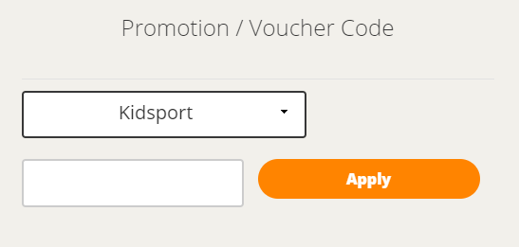
In the second box enter KIDSPORTBJCC21/22
You will see
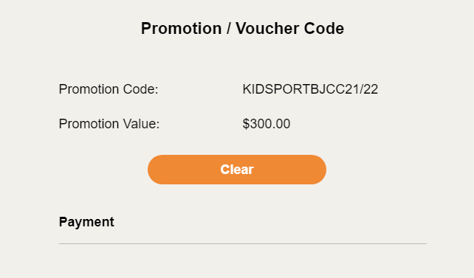

As you scroll down you will see.
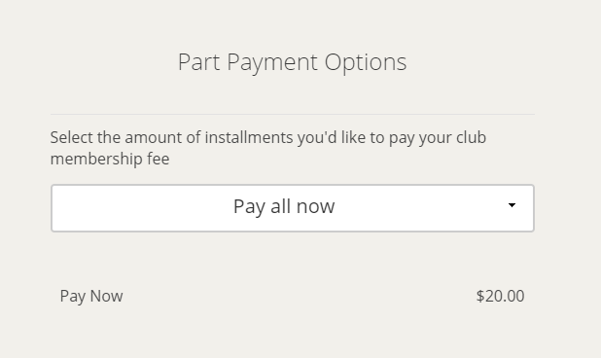
Play Cricket subtracts the $170 off the registration fee and informs you of the outstanding balance.
You can now completer the transaction to register your child.

Finally…..
Please email your Unique KidSport Voucher code with your child’s name to Jeremy Manning at treasurerbjcc@gmail.com
Once this is done, we can complete the KidSport Registration Process.
For any questions, please contact Jeremy; treasurerbjcc@gmail.com
Regards,

