KidSport Season 2021/22

The Below KidSport Registration process is only for Children playing Junior Blasters or Master Blasters.

Apply for the KidSport voucher as per:
https://www.dlgsc.wa.gov.au/docs/default-source/funding/kidsport/kidsport-brochure.pdf?sfvrsn=d56cd6a1_6
If you are successful you will receive a Unique KidSport Voucher code. Keep this code.
Head to Bjcc.net.au to register your child.
On the last page of the registration you will be asked for a “Promotion/Voucher Code”
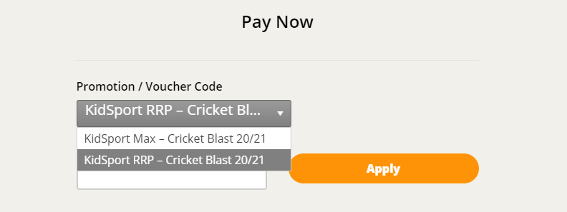
Select: KidSport RRP – Cricket Blast 21/22
Then enter: 2021KIDSPORT in the second box.
You will see
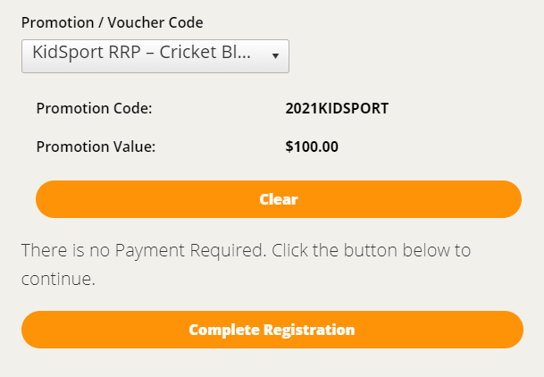
Play Cricket subtracts the $99 off the registration fee and informs you of the outstanding balance.
You can now completer the transaction to register your child.

Finally…..
Please email your Unique KidSport Voucher code with your child’s name to Sue Carson at treasurerbjcc@gmail.com
Once this is done, we can complete the KidSport Registration Process.
For any questions, please contact Sue; treasurerbjcc@gmail.com
Regards,

